ARTIFICIAL INTELLIGENCE.

**What is artificial intelligence?**

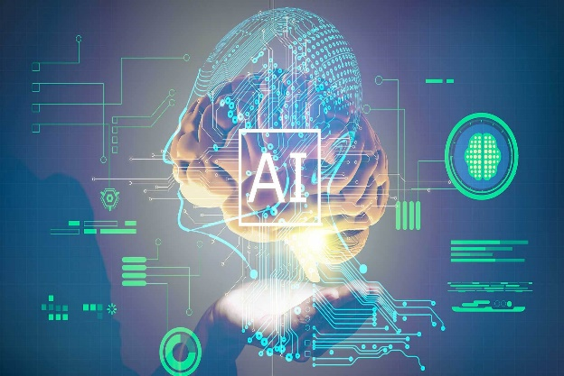

**Artificial intelligence (AI)** is the theory and development of computer systems capable of performing tasks that historically required human intelligence, such as recognizing speech, making decisions, and identifying patterns. AI is an umbrella term that encompasses a wide variety of technologies, including [machine learning](https://www.coursera.org/articles/what-is-machine-learning), [deep learning](https://www.coursera.org/articles/what-is-deep-learning), and [natural language processing (NLP)](https://www.coursera.org/articles/natural-language-processing).

Although the term is commonly used to describe a range of different technologies in use today, many disagree on whether these actually constitute artificial intelligence. Instead, some argue that much of the technology used in the real world today actually constitutes highly advanced machine learning that is simply a first step towards true artificial intelligence, or “general artificial intelligence” (GAI).

Yet, despite the many philosophical disagreements over whether “true” intelligent machines actually exist, when most people use the term [AI](https://www.coursera.org/articles/what-does-ai-stand-for) today, they’re referring to a suite of machine learning-powered technologies, such as [Chat GPT](https://www.coursera.org/articles/chatgpt) or computer vision, that enable machines to perform tasks that previously only humans can do like generating written content, steering a car, or analyzing data.

**Father of A.I?**

John McCarthy.



A.I Release Date.

29 June 2001.

### Artificial intelligence examples

Though the humanoid robots often associated with AI (think *Star Trek: The Next Generation’s* Data or *Terminator’s*  T-800) do not exist yet, you have likely interacted with machine learning-powered services or devices many times before.

At the simplest level, machine learning uses [algorithms](https://www.coursera.org/articles/machine-learning-algorithms) trained on data sets to create [machine learning models](https://www.coursera.org/articles/machine-learning-models) that allow computer systems to perform tasks like making song recommendations, identifying the fastest way to travel to a destination, or translating text from one language to another. Some of the most common examples of AI in use today include:

* [ChatGPT](https://www.coursera.org/articles/chatgpt)**:** Uses large language models (LLMs) to generate text in response to questions or comments posed to it.
* **Google Translate:** Uses deep learning algorithms to translate text from one language to another.
* **Netflix:** Uses machine learning algorithms to create personalized recommendation engines for users based on their previous viewing history.
* **Tesla:** Uses computer vision to power self-driving features on their cars.

## What is artificial general intelligence (AGI)?

Artificial general intelligence (AGI) refers to a theoretical state in which computer systems will be able to achieve or exceed human intelligence. In other words, AGI is “true” artificial intelligence as depicted in countless science fiction novels, television shows, movies, and comics.

As for the precise meaning of “AI” itself, researchers don’t quite agree on how we would recognize “true” artificial general intelligence when it appears. However, the most famous approach to identifying whether a machine is intelligent or not is known as the Turing Test or Imitation Game, an experiment that was first outlined by influential mathematician, computer scientist, and cryptanalyst Alan Turing in a 1950 paper on computer intelligence. There, Turing described a three-player game in which a human “interrogator” is asked to communicate via text with another human and a machine and judge who composed each response. If the interrogator cannot reliably identify the human, then Turing says the machine can be said to be intelligent.

To complicate matters, researchers and philosophers also cannot quite agree whether we’re beginning to achieve AGI, if it’s still far off, or just totally impossible. For example, while a recent paper from Microsoft Research and Open AI argues that Chat GPT-4 is an early form of AGI, many other researchers are skeptical of these claims and argue that they were just made for publicity.

Regardless of how far we are from achieving AGI, you can assume that when someone uses the term artificial general intelligence, they are referring to the kind of sentient computer programs and machines that are commonly found in popular science fiction.

**What is general AI?**



Artificial general intelligence (AGI), or strong AI, is still a hypothetical concept as it involves a machine understanding and performing vastly different tasks based on accumulated experience. This type of intelligence is more on the level of human intellect, as AGI systems would be able to reason and think like a human.

**Also:**[**AI's true goal may no longer be intelligence**](https://www.zdnet.com/article/ai-true-goal-may-no-longer-be-intelligence/)

Like a human, AGI could potentially understand any intellectual task, think abstractly, learn from its experiences, and use that knowledge to solve new problems. Essentially, we're talking about a system or machine capable of common sense, which is currently unachievable with any available AI.

Developing a system with consciousness is still, presumably, a fair way in the distance, but it is the ultimate goal of AI research.

**What is super AI?**



Artificial superintelligence (ASI) is a system that would not only rock humankind to its core but could also destroy it. If that sounds like something straight out of a science fiction novel, it's because it kind of is. ASI is a system where the intelligence of a machine surpasses all forms of human intelligence in all aspects and outperforms humans in every function.

**How is artificial intelligence changing the world?**

* Artificial intelligence is already altering the world and raising important questions for society, the economy, and governance. AI generally is undertaken in conjunction with machine learning and data analytics. 5 Machine learning takes data and looks for underlying trends.

**How will AI change the world?**

* AI is becoming more powerful and radically cheaper by the month—what was computationally impossible, or would cost tens of millions of dollars a few years ago, is now widespread. These AIs will organize a retirement party and manage your diary, they will develop and execute business strategies, whilst designing new drugs to fight cancer.

**Is the future of AI a rapidly changing landscape?**

* If it feels like the future of AI is a rapidly changing landscape, that’s because the present innovations in the field of artificial intelligence are accelerating at such a blazing-fast pace that it’s tough to keep up. Indeed, artificial intelligence is shaping the future of humanity across nearly every industry.